

User Interface Design -23CSE113

Project documentation

Submitted By
NAME | P. BHANU KIRAN
ROLL NO | AV.SC.U4CSE25142
YEAR/SEM/SECTION | 1ST YEAR/ SEM-2/CSE-B
CREDITS | 03

Submitted to
NAME | DR. RAJ KUMAR BATCHU
DESIGNATION | ASST.PROFFESSOR (Sl. Grade)
DEPARTMENT | SCHOOL OF COMPUTING

Body
- Min-height: 100vh, this sets the minimum height of the body to the entire screen size.
- Display: Flex and Flex-direction column is used to provide responsiveness.
- For all the elements the margin, padding are initially set to 0 so that later we can provide it later according to requirement.
- Box-sizing: Border box, this calculates the total width and height as (content+padding+border) content-box(default), width and height only apply to content area.

Header
- Unordered list is used for links to other pages.
- Position: sticky, this sticks the position of certain element even when page is scrolled. This only works if the position is specified like top:0
- Z-index: 10, This moves the header upwards in the z-direction so that when elements will pass from below header.
- For the button margin-left: auto is used, if the parent element has display flex then margin-left:auto will push that element to the far-right edge.


Aurora effect
- To get the aurora effect 4 div’s are placed side by side with border-radius:50%
- For each color div opacity is set to decrease opacity.
- Filter: blur(100px), this is responsible for aurora like effect.
- All these 4 div’s are placed inside div which is kept at the very top position: relative, is used to place it at desired location top: -70% , is used to that only bottom 30% is visible.
- Overflow: hidden, this hides the extra content coming out of box.
- For animation the locations of the color div’s are changed for the moving effect.


Name
- The main logo and text and color effect is stored in this div.
- It’s position is said to relative for the color effect position: absolute to work.
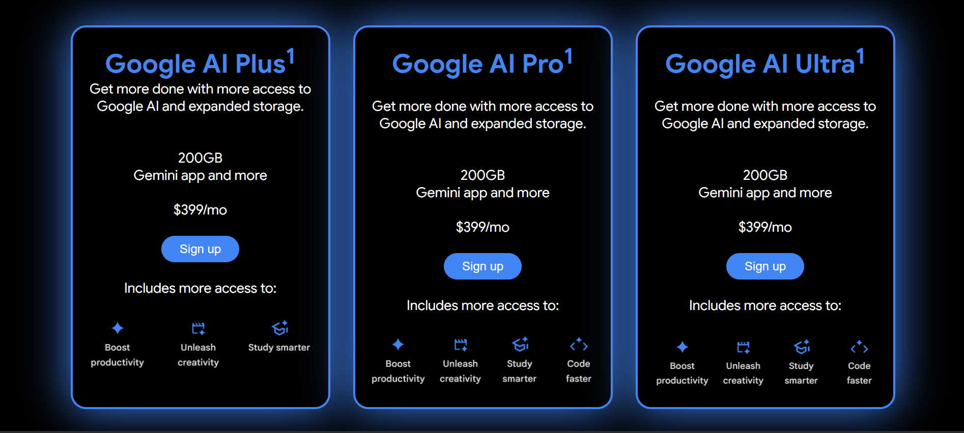

Plans
- The entire blue text in the code is written inside span tag. It is a inline element and the color of span is blue.
- Justify content is used to align horizontally.
- Align-items: center should not be used here, if it is used all plan-cards will not be of same height.
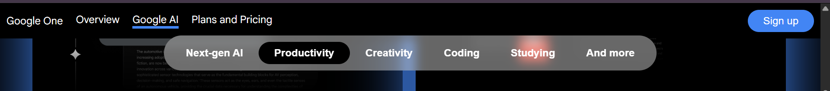

Feature-scroll
- This is known a scroll spy, its position is sticky and its location is right below header. Since it is inside cards div, it works as long as we scroll cards div.
- Links with id’s are used so that onclicking them takes to that locatin
- Z-index: 10, same reason as the header.
- Backdrop-filter: blur(30px) this gives the element glass effect if only works when the background color, if opacity is used then the content opacity is also changed.
- Flex-wrap: wrap, if the elements don’t have enough space then this makes them move to the next line.
- Width: 100%, this tells the element to occupy the all available width of the parent element occupying the entire row, the remaining elements gets sent to the next line, this only works if the flex-wrap: wrap
- The cards inside each category have position realative and the + buttons inside them absolute to have the button location at bottom right.
- Every card has a div with class hidden.
- Display: none, this hides the content.
- Card no: hover .button2{transform: scale(1,1);}, this slightly makes the button bigger when zoomed this only works only if the .button2 is the child element of .cardno
- On hovering certain element when some another unrelated elememt should show change then instead of javascript we can use body:has(#element1 : hover) #ele2 :has() is a pseudo class called the parent selector.
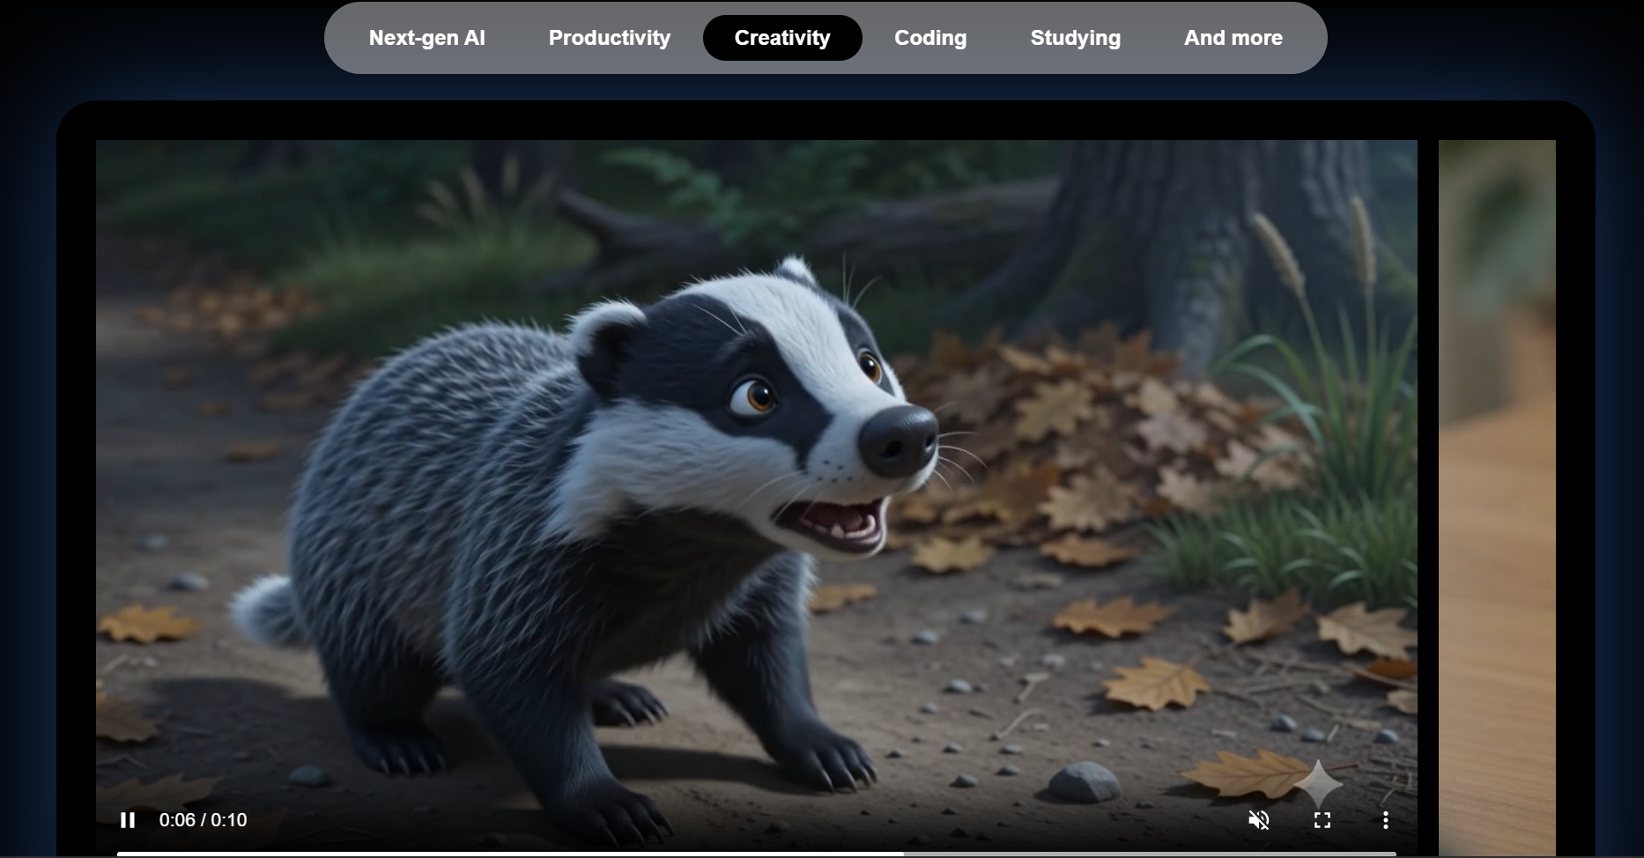

Carousel
- overflow-x: auto,scroll bar only appears if the content actually overflows the width in horizontal direction.
- Scroll bar-width: none, this removes the normal scroll bar.
- Scroll-snap-type: x mandatory, x is direction and mandatory is strictness, x snaps horizontally.
Mandatory => when we pause scrolling between two elements, it automatically glides to closest one

Comparision-table
- Colgroup, in this tag we can group the columns. In the colgroup tag <col> represents the complete column respectively. This is used to apply style to entire column.
- If multiple columns need to be grouped span=” “
- thead and tbody are sematic tags which are used to organise table.
- If the table border radius is set, the content may overflow from the corner elements. So overflow: hidden need to be set for corner elements.
- Border-collapse: collapse, the double border between cells will become single border.
- td: not(:first-child), this means all td’s in the rows except first one.
- Header position is sticky and sticks at top as long as we scroll through header.

Javascript
- Element.query selector(#id) , searches the element and returns the first element with id, classname or tag name can also be used.
- Item.classList.toggle(‘hidden’), classlist can make changes to classes of item. If toggle is used, if item contains the class, it will be added else it will be removed
- var element = document.get.Elements ByClassName(‘.item’), even though there is only, element is list and it will be stored in that, should be accesses as element[0]
- In the showAllShow() function element is a list contaning elements with class given to toggle hidden for all of them for loop is used

